Activity 17

NAME : Sybil Litzy A COURSE : Mobile Computing
Reg No : 192421110 COURSE CODE: ITA0301

Create a visual representation in Figma illustrating the operation of proactive and reactive routing protocols in mobile IP

Aim:
Create a visual representation in Figma illustrating the operation of proactive and reactive routing protocols in mobile IP.

Procedure:
- Define Presentation Structure
- Create a Figma Project
- Design Visual Elements
- Make it Interactive
- Add Annotations and Explanations
- Incorporate Multimedia
- Storyboard Animation
- Test the Prototype
- Collaborate and Gather Feedback
- Finalize and Share

Step By Step Procedure : Interface Of Experiment:
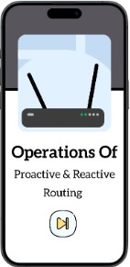

Next Page:

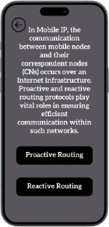

Final Step:
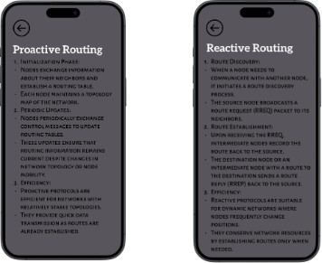

Prototype:

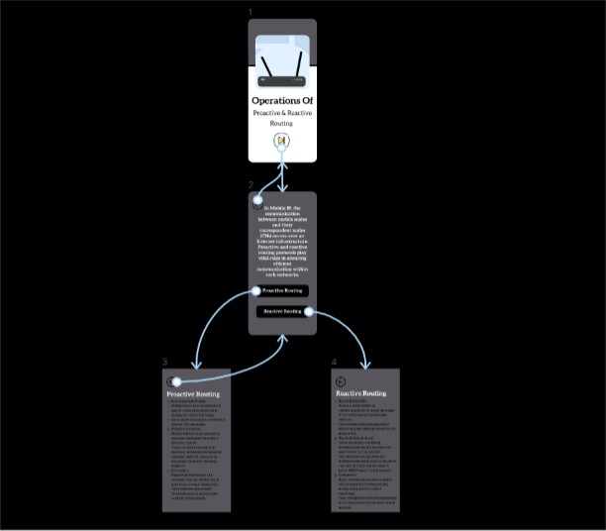

Result:
Hence the illustrating the operation of proactive and reactive routing protocols in mobile IP is created and executed successfully

